IC 7806
CP018
Image:
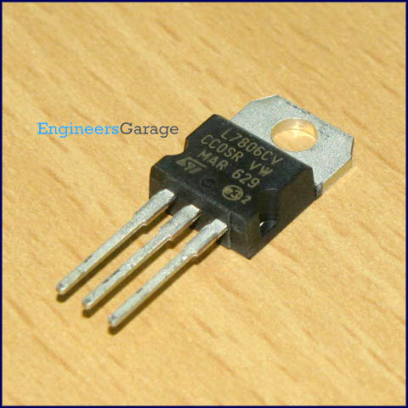
DataSheet:
7806.pdf
7806 is a voltage regulator integrated circuit. It is a member of 78xx series of fixed linear voltage regulator ICs. The voltage source in a circuit may have fluctuations and would not give the fixed voltage output. The voltage regulator IC maintains the output voltage at a constant value. The xx in 78xx indicates the fixed output voltage it is designed to provide. 7806 provide +6V regulated power supply Capacitors of suitable values can be connected at input and output pins depending upon the respective voltage levels.

Pin Diagram:
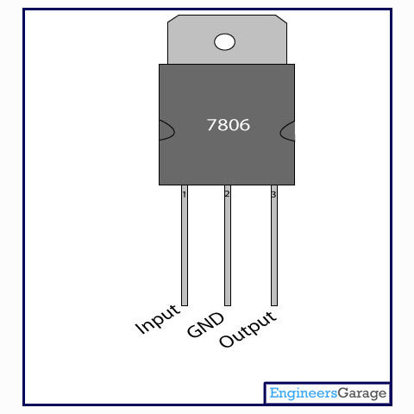
Pin Description:
Pin No. | Function | Name
1 | Input voltage (5V-18V) | Input
2 | Ground (0V) | Ground
3 | Regulated output; 6V (5.75V-6.25V) | Output

